Table of Content

Introduction ………………………………………………………………………………. 6

Key Requirements of the App ………………………………………………………….. 6 – 10

Design of the interface 11 – 15

Login Page ……………………………………………………………………….. 11

Registration ………………………………………………………………………. 12

Entering Daily Activities or Food Intake ……………………………………….. 13 – 14

Result Page ………………………………………………………………………. 15

Evaluation Methods ……………………………………………………………………… 16

Evaluation Results 16 – 19

Online Questionnaire ……………………………………………………………. 16 – 17

Paper Prototype (Observation and Interview) ………………………………… 17 – 19

Heuristic Evaluation 29 – 38

Lew Wei Moong ………………………………………………………………….. 20 – 25

Aditya Loh ………………………………………………………………………… 26 – 32

Tan Song Yan ……………………………………………………………………. 32 – 38

Reflection …………………………………………………………………………………. 39

Appendixes 40 - 50

A: References ……………………………………………………………………………. 40

B: Questionnaire Design ……………………………………………………………….. 41 – 43

C: Questionnaire Responses ………………………………………………………….. 44 – 46

D: Paper ProtoType …………………………………………………………………….. 47

E: Final Design of the Interface ………………………………………………………. 48 – 50

Introduction

This individual assessment talks about a major problem that some said it is caused by calorie tracking apps which is eating disorder. Since the question did not specify whether do we design or redesign the interface of an application, I would assume that it asks us to design an application that can serve as a calorie tracking app that does not give their users eating disorder like other apps. The application that I decided to call is Fitlorie Diary which is a combination of fitness and calorie combine into one.

Key Requirements of the App

Problems and challenges of the app

The main problem that applications like My Calorie Dairy which is a calorie counter application is that their users are complaining that their eating disorder are caused by using the applications. People who uses these kinds of application have only one intension which is to lose weights and it is also the targeted users that companies who developed these applications are focusing. The reason why these people have eating disorder and are blaming these applications for their faults is because they think by following these steps (even though the applications stated that it will be accurate) will allow them to achieve what they are hoping for.

Functional and Non-Functional Requirements

Developing or redesigning an interface has to prioritize setting the system ‘s functional and non-functional requirements to define what is the scope of the system. It also ensures that the end product does not end up differently then what has already been defined.

Functional Requirements

|  |  |
| --- | --- |
| ID No | Description |
| FR 001 | Users shall be able to set their own goals to achieve |
| FR 002 | The system shall predict what are the activities or diet option based on the user behaviours. |
| FR 003 | The interface shall have a home page to display data gathered throughout the day of the user. |
| FR 004 | When 24 hours have been passed, a new record shall be entered by the user. |
| FR 005 | User shall be able to fully customize the interface to their preferences |

Non-Functional Requirements

|  |  |
| --- | --- |
| ID No | Description |
| FR 001 | The server must accommodate a minimum of 1 million concurrent user. |
| FR 002 | Each page shall load within 5 seconds |
| FR 003 | The background colours of all page shall be #FFEA61 |
| FR 004 | Password should follow the format given i.e. at least one capital letter. |
| FR 005 | The layout shall allow user to access their profile date within 3 clicks. |

Stakeholder Analysis

The stakeholders that I have analysis was mentioned previously which are people who have a goal in mind to either lose some weight or achieve their fitness goal. These people are the customers of the application who are interested in the services provided by this application. Depending on the feedbacks received by the customers, the application could receive major or minor updates. The other stakeholder is the employees that are working in for the company. Since it did not state any company, I would assume that the company employs people to develop the application while they can earn incomes to support themselves or their families.

Data Requirement

The data that the system needs to access to achieve the scope of this application will be the data the user enter. For example, a user enter their daily activities and food intakes every day. The system will be able to predict how their diet plan will take hold. The data will also be useful for health professional who can do research about these eating disorder.

Task Analysis

The task analysis will be described like as how a user is already using the interface to register and to enter their daily activities and food intakes.

Registration

1. Open the application

2. Click on side menu

2.1 Click on Register

2.2 Enter full name

2.3 Enter gender

2.4 Enter email

2.5 Enter password

2.6 Enter confirm password

2.7 Click Register to proceed

3. Enter daily activity

Plan 2: if user wants to register, do 2

If user enters a password that does not match, do 2.6 again

Entering daily activities and food intake

1. Open the application

2. Enter daily activities and food intake

2.1 Eat 2 eggs and 1 apple for breakfast

2.2 Workout for 2 hours

2.3 Drink 2 litres worth of water

2.4 Eat salad for lunch

2.5 Eat roasted chicken and vegetables for dinner

2.6 Confirm

3. View the result of the day

3.1 View nutrient intake

3.2 View calories limit

3.3 Plan for the next day

Plan 2: if user enters wrong activity or food intake like 2.2, they can edit it

Environment Requirement

There are 4 aspects of the environment to consider which are physical, social, organizational, and technical. As for the physical and organizational side, it will depends where they are doing their activities, for example, they could be at a gym working out which could make the environment noisy and busy or they could be at home eating breakfast which could make the environment either quiet or noisy. For the social side, it mostly involved the employees working on developing the application. Lastly, the technical environment that the product will be running on will be on mobile platform to serve convenience.

User Characteristic

Users who uses any calorie tracking application as mentioned previously has either a fitness goal or just wants to lose some weight. There are many age groups to consider but if I would narrow down the range, it would be between 19 to 50 years old. The skill level of these users also needs to take into consideration whether they are veterans who comfortably deals with technology where the age group of these could fall in between 19 to 30 years old to users who are poor at dealing with technology where the age group of these could fall between 40 to 50 years old.

Usability Goals

The system needs to be simple for users who are 40 to 50 years old of that age group due to their lack of skill in using technologies. As for users who are in the age group of 19 to 30 years old, the system should be more efficient the more they use. It also tides in with them memorizing how the interface works which will increase their efficiency by a bit. Since the data will be depending on users’ inputs, the ability to prevent any misinput enter to get an accurate result rather than misleading one.

Design of the interface

Login Page

This is the login page for the application. The text box where users enter their email and password has a small animation where the edges of the box will become rounded just like the image above. It will turn back into a square once the user has finish entering their details. When user is entering their details, the text box will change to red to white indicating input is being entered. A message will appear to alert users when they have entered a wrong email or password. The button to proceed will also greyed out when there is an error to prevent users from proceeding. It will turn back to red once the error has been solved.

Registration

This is the registration page. Both the login and registration page has the name of the application as the header. This design is used by many designers too. A white background is behind the text and text box to make them ‘pop’ and prevent users from getting distracted from the colours. The text boxes on the Registration page is the same as the Login page where there is a small animation and colour changes when users interact with them. The button function is also the same, it will be greyed out to prevent users from proceeding if there is an error input. It will also turn back to red once the error has been solved.

Entering Daily Activities or Food Intake

This is where users will enter their daily activities or food intake each day. Top of the application is the name of the application, a side menu which was requested during the observation, a pencil icon where users can click on it to write some notes, and the three dots that is widely used as a option icon. Below that is the date of the day the user enter. Below the date is the calorie tracking is at where it displays the goal set by the user, the total calories of food intake, and the remaining calories left. Even below that are the items that user have entered throughout the day. The reason for why linear design is because it allows the user to be able to read the information easier since the more items they add, the longer the list will get. Most list are in a linear design and people tend to read from up to down when there is more information downward. When user click on Add Food, they will be bought to a page where they can enter their food name, the number and size of serving. It also displays the macro of the food entered.

After confirming the entry, the newly added food item will be display on the home screen. When user click on the side menu, an animation will occur to bring out the menu and rotates the side menu icon 90o. In the side menu, it contains Home, Profile, Results, and Setting. User can also log out by clicking on the side menu where the option is at the bottom. Based on the non-functional requirement mentioned, users can go to their Profile within 3 clicks by simply clicking on the side menu and Profile.

Result Page

This is the result page where users can view the end result of the day. Depending on the entries by the users, the graph will be different every time. The online tool to make this wireframe does not have the ability to make a pie chart that shows different colours but in the actual application, the graph will show different colours depend on the macros, for example, blue represents protein and so on. The summary of food intake or daily activities was mentioned during the observation is also added just like the side menu.

One of the reasons why the colour scheme of the background is yellow is because I mentioned that all background shall be in #FFEA61 (which is the colour code for yellow) in the functional requirement. Red text boxes is because red contrasts well with yellow.

Evaluation Methods

The evaluation or data gathering methods used to get information for the development of the application will be online questionnaire, observation, and interview. The timeframe for some of the methods is quite limited where it gave us only 2 days to design an interface for the application. Since the questionnaire is online based, it should be easy to get at least 10 users by sharing it with friends or family members. As for observation and interview, I will be conducting a paper prototyping. What it meant by that is I will draw parts of the interface and show it to some users. I would then brief them what each interface do and observe them. At the end of the session is where the interview part comes where I asked them some short questions. Heuristic evaluation will also be conducted to get even more usability testing on the application.

Evaluation Results

Online Questionnaire

I have designed an online questionnaire to gather some information whether they use a calorie tracking app before or not. There were a total of 10 responses that answer this questionnaire. Since this questionnaire does contains sensitive questions and also to protect people’s privacy, they can choose to opt out if needed. Example of questions are “ Do you ever use a calorie tracking app before” and “What do you like or dislike about the app?”. Below are some screenshots of the questionnaire:

The image from the right and the bottom last are the sensitive questions. Before answering for the question “Do you have an eating disorder (mental illness)”, there will be a question for people to opt out if they feel unsecure. Some of the responses will reach till question 2 is because when they select No when I asked them does they use a calorie tracker app before, it will submit form. This eliminates any people who are inexperienced. In the end, 5 respondents answer the entire questionnaire even though knowing there would be sensitive questions. Among all the questions, the last one is important where it ask if health professional is necessary to be involved in developing these kinds of apps and the results is that all 5 respondents agree.

People who answered Yes when I asked do they use a calorie tracker app before, responded their reason of why they used the app. As mentioned, the number of respondents will probably be insufficient to do any research, but any data is still valuable. Therefore, majority of 5 people choose Diet Planning as their reason and only 1 chose eating healthier as their reason.

Paper Prototype

The image above is the paper prototype that I drew to get feedback from users. The interface I decided to draw are the Registration page, enter daily activities or food intake page and the result of the day page. Each user will be brief shortly on how these page works. For the registration is self-explanatory. As for the enter daily activities or food intake page, users can enter the foods they eat on that day and the system will do the math. At the end of the day, the result page will show the result of the day depending on the food the user eat.

I have asked some friends and family member to act as a user for this observation and interview session for the prototype. They are also in the target population that was mentioned in user characteristic. I would brief them on each interface after sending them each a picture of the interface. The reasons why the session is not a face-to-face is because of the MCO protocol which restricts us from interacting with one another. Hence, it will be done through application that allows video calls where I observe the subjects on figuring out what are the pros and cons of the interface. The first comment of one of the subjects made was that the interface looks decent. Since the prototype is paper based, the interacting level is different from a prototype that is coded. Hence, some of the comments will help in designing on how the interface would look like.

One of the subjects realize that the page where users enter their daily activities or food intakes does not have a side menu visible. He said that without a proper indication will confuse users on where to exit out of the page. Lastly, a subject commented that the result screen should show the food intakes or activities done to give a summary for the user to view back.

After the observation session ended, I would interview them with 2 – 3 questions about the interface itself. All the subjects have at least used one of the few calorie tracking apps before which can be helpful in redesigning the interface. The following are the few questions that I asked the interviewees:

1. What was the first impression when you saw the prototype?
2. What are the changes or implementation that you would like to see?
3. Do you prefer this interface or the one you used before and why?

Carole Tan, 25 years old, Fitness Instructor

Answer for Question 1:

Honestly, it looks better than I would imagine minus that the fact is in black and white and I know these kind of prototypes does not need to be all professional like. Overall, it looks nice.

Answer for Question 2:

There is not much I feel like it needs to change since I do not know much about interface design.

Answer for Question 3:

I would prefer the one I used before for now. If you would show me a working prototype, then maybe it would be a different story.

Rick Tan, 23 years old, Student in Bachelor’s in Interior Architecture and Design

Answer for Question 1:

Personally, it looks pretty good for someone knows how to draw. As someone who chose interior design as their major, the design could actually pass as an idea.

Answer for Question 2:

As I mentioned during the observation, I would like to see a hamburger that is a metaphor for any side menu to be implement for users to navigate easier.

Answer for Question 3:

I would prefer this one because I feel like there is a lot of possibilities for it.

Carl Lee, 26 years old, Accountant

Answer for Question 1:

For me who does not know much of what Human Computer Interface is, what I can see that this prototype looks alright for a first prototype without much idea.

Answer for Question 2:

I mentioned this during our observation session which is that a summary of the activities and food intake by the user can be put at the result page.

Answer for Question 3:

Each interface has its unique take in designing the app. If I would pick this one or the one I used before, I would choose this one because it has a user-friendly vibe to it.

Heuristic Evaluation

How I conducted heuristic evaluation is by asking 3 of my classmates to complete the evaluation by 10 May since I have only 2 days to complete all these requirements. Each of them has their own unique way of evaluating the prototype. Here are my classmates who took part in the evaluation:

Lew Wei Moong, Bachelor’s in Computer Science

Log in Page

Visibility of system status

- The visual of the application looks pretty good. The used of colours contrasts with each other. The design looks like a normal login page to me.

Match between system and the real world

- Icons for email and password is exactly what it should be.

User control and freedom

- The option to choose to create an account or reset password is visible, therefore, the user can choose when they want to reset their password if forgotten or register an account.

Consistency and standards

- The button for Log in does what it is meant to do which is to log in the user.

Error prevention

- An error message is displayed to help user from proceeding with an error.

Recognition rather than recall

- I can just look at this page and straight away knew it is a login page.

Flexibility and efficiency of use.

- The auto-fill option should be included which can fill the information from any input entered like entering an email

Aesthetic and minimalist design

- Minimal information is necessary for a login page so that it does not overwhelm the user.

Help users recognize, diagnose, recover from errors.

- Error message is showed in the interface that determines the password is wrong

Help and documentation

- Submitting any wrong inputs will disable the login buttons was also showed in here.

Registration

Visibility of system status

- The visual looks like the login page where I can see consistency.

Match between system and the real world

- The design of the form is a typical registration form with lesser stuff to fill in.

User control and freedom

- This page is only used when users want to register an account.

Consistency and standards

- The button for Register does what it is meant to do which is to register the user.

Error prevention

- An error message is displayed to help user from proceeding with an error which is the same as the login page.

Recognition rather than recall

- I can just look at this page and straight away knew it is a registration page.

Flexibility and efficiency of use.

- The auto-fill option should be included which can fill the information from any input entered like entering an email

Aesthetic and minimalist design

- Minimal information is necessary for a registration page so that it does not overwhelm the user.

Help users recognize, diagnose, recover from errors.

- Error message is showed in the interface that determines the password is wrong

Help and documentation

- Submitting any wrong inputs will disable the login buttons was also showed in here.

Entering Daily Activities or Food Intake

Visibility of system status

- It looks like a calorie tracking app I used before which is a good thing.

Match between system and the real world

- The pen has different meaning but I can see what the meaning for this interface is.

User control and freedom

- The user has all the freedom to choose their food to enter.

Consistency and standards

- The side menu does what the side menu does.

Error prevention

- User can cancel the entry by clicking on the X icon.

Recognition rather than recall

- It looks like a journal for people to write their food intake.

Flexibility and efficiency of use.

- The auto-fill option should be included which can fill the information from any input.

Aesthetic and minimalist design

- Minimal information is necessary for this kind of page so that it does not overwhelm the user.

Help users recognize, diagnose, recover from errors.

- No clear error message showed in the prototype.

Help and documentation

- Submitting any wrong inputs will disable Tick icon to prevent user from entering incomplete details.

Result Page

Visibility of system status

- It looks like a typical health monitor result screen where it have the calories gained and all.

Match between system and the real world

- The pie chart is used by many companies to display information

User control and freedom

- User can choose to view the result screen or not and the result is based on the entries entered by the user.

Consistency and standards

- It does not show the side menu but it does what the side menu does.

Error prevention

- There is nothing the user can do here instead of looking at the data.

Recognition rather than recall

- It looks like a typical health monitor result screen

Flexibility and efficiency of use.

- The efficiency would probably stay the same since it only displays data.

Aesthetic and minimalist design

- Data is crucial in this page but minimal information is also important

Help users recognize, diagnose, recover from errors.

- No clear error message showed in the prototype.

Help and documentation

- No clear help option is visible in this page since it shows the end result to the user.

Aditya Loh, Bachelor’s in Computer Science

Log in Page

Visibility of system status

- Overall, the login page looks great. There is not much distraction in the page.

Match between system and the real world

- The usage of the icons for email and password is a metaphor used by many designers.

User control and freedom

- User have the freedom to either login if they have an account or register an account.

Consistency and standards

- The usage of button does what a button would do which is to proceed to a next or previous page.

Error prevention

- A clear error message is showed in the prototype.

Recognition rather than recall

- The classic login page is easily recognizable from my perspective. Others would think differently.

Flexibility and efficiency of use.

- An auto-fill option should allow user to not type the entire thing if necessary.

Aesthetic and minimalist design

- Login page does not need much information displayed on the screen.

Help users recognize, diagnose, recover from errors.

- The error message will help the user in figuring out what is wrong.

Help and documentation

- When user enter a wrong input, the page will not proceed to the next page and if it is being corrected, it will proceed.

Registration

Visibility of system status

- Overall, the registration page looks similar to the login page in terms of colours.

Match between system and the real world

- The design of the registration page is similar to any registration form.

User control and freedom

- The user is free to go back to the previous step of the text field to correct their mistake.

Consistency and standards

- The usage of button does what a button would do which is to proceed to a next or previous page.

Error prevention

- A clear error message is showed in the prototype.

Recognition rather than recall

- The classic registration page is easily recognizable from my perspective. Others would think differently.

Flexibility and efficiency of use.

- An auto-fill option should allow user to not type the entire thing if necessary.

Aesthetic and minimalist design

- Registration page does not need much information displayed on the screen.

Help users recognize, diagnose, recover from errors.

- The error message will help the user in figuring out what is wrong.

Help and documentation

- When user enter a wrong input, the page will not proceed to the next page and if it is being corrected, it will proceed.

Entering Daily Activities or Food Intake

Visibility of system status

- It does not look distracting which is good. It shows the amount of calories taken and the remaining which let the user to keep track of their goal.

Match between system and the real world

- The language display in the prototype is English where I am able to understand.

User control and freedom

- The user can either add or delete a food item on their free will.

Consistency and standards

- Side menu are seen everywhere in mobile application to hide unnecessary information for certain pages.

Error prevention

- User can exit out or cancel their entry by clicking on the cross icon on the top right.

Recognition rather than recall

- From my perspective, it looks like a diary where users normally writes their food intakes or activities.

Flexibility and efficiency of use.

- An auto-fill option should allow user to not type the entire thing if necessary.

Aesthetic and minimalist design

- The design is I think the minimalist point where users view this page is for one purpose which is to keep track of their calories gain.

Help users recognize, diagnose, recover from errors.

- No specified error in this prototype but an error message could appear when a user did not fully fill in the text boxes.

Help and documentation

- Submitting incomplete entry will not allow the user to continue.

Result Page

Visibility of system status

- The information displayed is big and clear which is necessary for people who have visual issues.

Match between system and the real world

- Many companies in the real world uses pie chart to compile their information.

User control and freedom

- They can save the current result for future references or not.

Consistency and standards

- The side menu operates the same as the previous interface although it did not showed in this prototype.

Error prevention

- Not much error prevention I can see happening in this page.

Recognition rather than recall

- From my perspective, it looks like those health screen in smart watches.

Flexibility and efficiency of use.

- Maybe veteran user will know each data immediately compared to new users.

Aesthetic and minimalist design

- Displaying data is the only thing happening in this page which is also why it is important to keep it minimal.

Help users recognize, diagnose, recover from errors.

- Not much error will occur in this page

Help and documentation

- It is the end result page which normally does not require much help.

Tan Song Yan, Bachelor’s in Computer Science

Log in Page

Visibility of system status

- My opinion is that the interface looks good. It has all the necessary message displayed.

Match between system and the real world

- The icon represents well with the email and password.

User control and freedom

- The users can freely delete their entry and re-enter it again.

Consistency and standards

- The button is used for a lot of things from the cancelling a process to proceeding.

Error prevention

- Clear error message is shown in the prototype

Recognition rather than recall

- I think it looks like any login page I seen.

Flexibility and efficiency of use.

- I believe an auto-input option is necessary to make the user completing the process faster.

Aesthetic and minimalist design

- I was feel that minimum information is necessary in mobile application to prevent overloading the user and this page does it.

Help users recognize, diagnose, recover from errors.

- The incorrect password or email will help the user to solve any problem.

Help and documentation

- Any wrong input by the user will be stopped by the system and guided to solve the problem.

Registration

Visibility of system status

- My opinion is that this interface also looks good. It has all the necessary message displayed.

Match between system and the real world

- The design of the form used in this registration page looks accurate to any registration form out there.

User control and freedom

- The users can freely delete their details entered and re-enter it again.

Consistency and standards

- The button is used for a lot of things from the cancelling a process to proceeding.

Error prevention

- Clear error message is shown in the prototype

Recognition rather than recall

- I think it looks like any registration page I seen.

Flexibility and efficiency of use.

- I believe an auto-input option is necessary to make the user completing the process faster.

Aesthetic and minimalist design

- I always feel that minimum information is necessary in mobile application to prevent overloading the user and this page does it.

Help users recognize, diagnose, recover from errors.

- The incorrect password or email will help the user to solve any problem.

Help and documentation

- Any wrong input by the user will be stopped by the system and guided to solve the problem.

Entering Daily Activities or Food Intake

Visibility of system status

- The design looks simple enough to understand what is the function of this interface.

Match between system and the real world

- I can read the language displayed in the prototype which is also the language used in the real world.

User control and freedom

- The users can freely delete or add their entry and re-enter it again.

Consistency and standards

- The side menu contains those links for users to click on is similar to many applications.

Error prevention

- The error message not shown here but probably it prevents user from submitting incomplete entries.

Recognition rather than recall

- I can recognize this interface to be an entry where users enter their food intakes.

Flexibility and efficiency of use.

- I believe an auto-input option is necessary to make the user completing the process faster.

Aesthetic and minimalist design

- I always feel that minimum information is necessary in mobile application to prevent overloading the user and this page does it.

Help users recognize, diagnose, recover from errors.

- The incomplete text boxes will alert the user to solve the problem.

Help and documentation

- Any wrong input by the user will be stopped by the system and guided to solve the problem.

Result Page

Visibility of system status

- The design looks simple enough to understand what is the function of this interface.

Match between system and the real world

- I can read the language displayed in the prototype which is also the language used in the real world.

User control and freedom

- Not much that the user can control because this page shows the result screen for the entries entered by the user.

Consistency and standards

- The side menu contains those links for users to click on is similar to many applications.

Error prevention

- Not much error to prevent in this page.

Recognition rather than recall

- I can recognize this interface to be an entry where users views their results at the end of the day.

Flexibility and efficiency of use.

- The speed would probably be the same, even as a veteran user.

Aesthetic and minimalist design

- I always feel that minimum information is necessary in mobile application to prevent overloading the user and this page does it.

Help users recognize, diagnose, recover from errors.

- Result screens usually does not have much error to get help from.

Help and documentation

- If there is any error occur in the result screen, it could possibly be a system error.

Reflection

This alternative assignment that replaces our final for this subject basically tells us the design process on how designers and developers work together to develop an application as the end product. However, these kinds of task requires months or least years and not measly 2 days and a degree student to be able to do. Clear instruction is also crucial to prevent your designers and developer from getting confuse whether it is about redesigning or designing an interface, it was be stated clearly. I am probably not the only one that thinks this assignment requires more time and the instruction is confusing. There is more things I would like to nit-pick about this assignment, but that should do it. Overall, it was a tough experience trying to complete everything in under 48 hours from collecting questionnaire responses to asking friends and family members to help with the paper prototype.

Appendixes A: References

1. Medium. 2020. *How To Conduct Heuristic Evaluation*. [online] Available at: <https://uxplanet.org/how-to-conduct-heuristic-evaluation-85548a355dca> [Accessed 9 May 2020].
2. Medium. 2020. *Color Matters. 6 Tips On Choosing UI Colors.*. [online] Available at: <https://uxplanet.org/color-matters-6-tips-on-choosing-ui-colors-260f56197a7b?gi=46ce59f65f6e> [Accessed 10 May 2020].
3. QRA Corp. 2020. *Functional Vs Non-Functional Requirements: The Definitive Guide - QRA Corp*. [online] Available at: <https://qracorp.com/functional-vs-non-functional-requirements/> [Accessed 9 May 2020].
4. Guru99.com. 2020. *What Is A Functional Requirement? Specification, Types, EXAMPLES*. [online] Available at: <https://www.guru99.com/functional-requirement-specification-example.html> [Accessed 9 May 2020].
5. 2002. *Interaction Design - Beyond Human-Computer Interaction*. 5th ed. [ebook] John Wiley & Sons, Inc. Available at: <https://arl.human.cornell.edu/879Readings/Interaction%20Design%20-%20Beyond%20Human-Computer%20Interaction.pdf> [Accessed 10 May 2020].

Appendixes B: Questionnaire Design

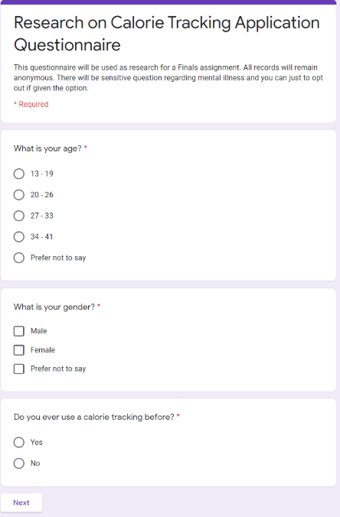

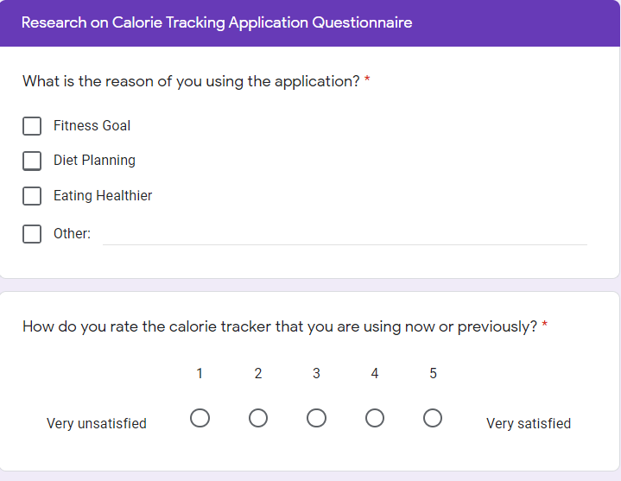

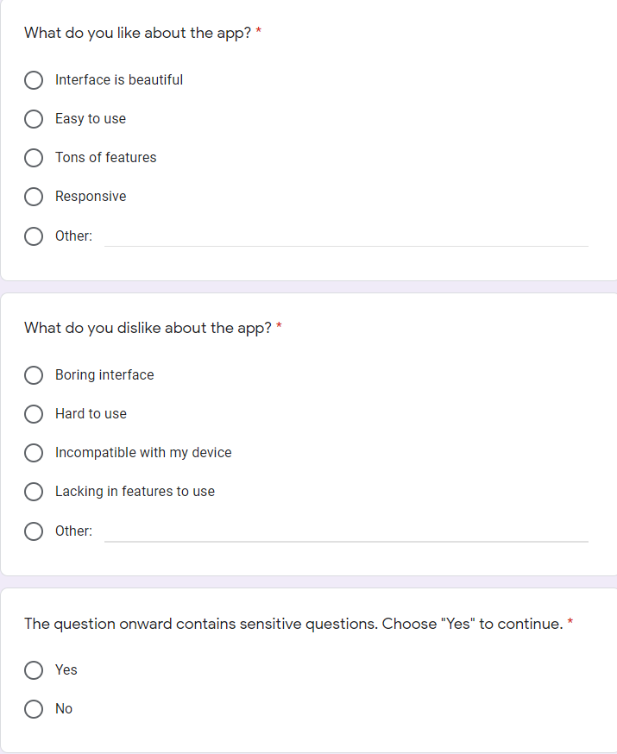

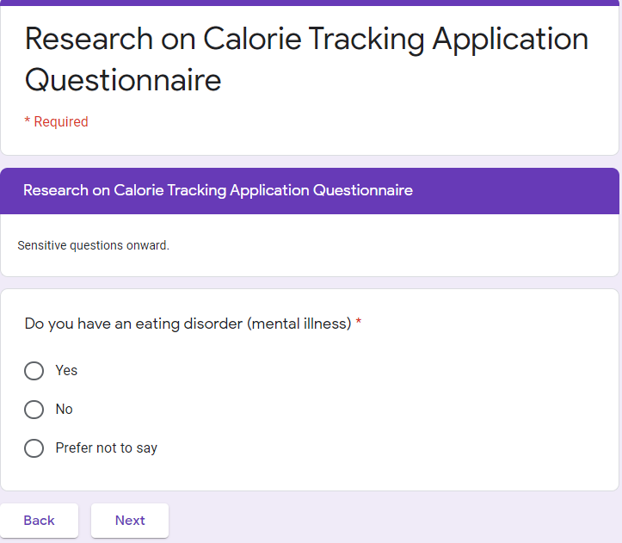

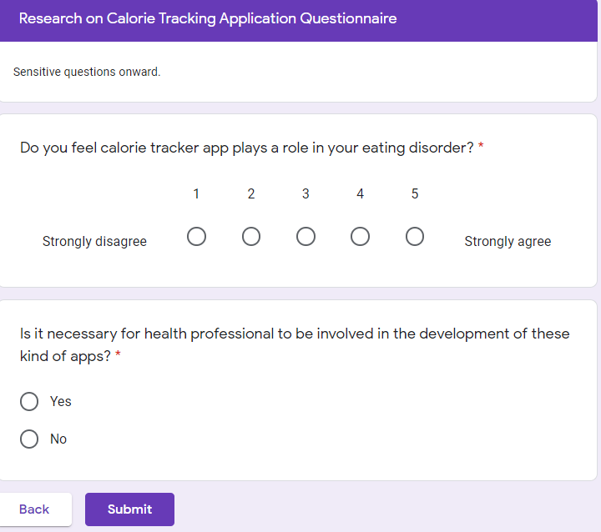

Appendixes C: Questionnaire Responses

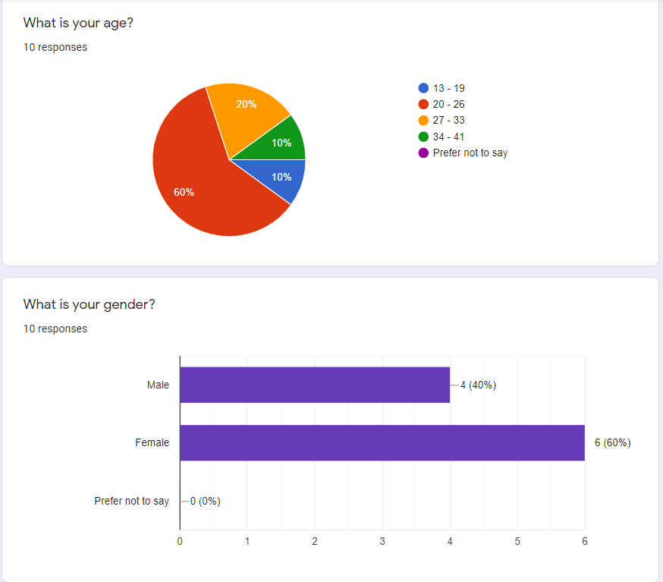

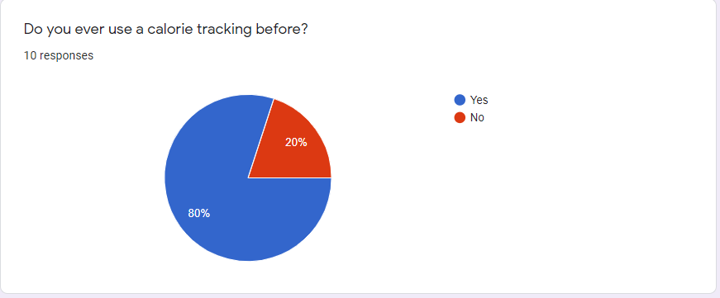

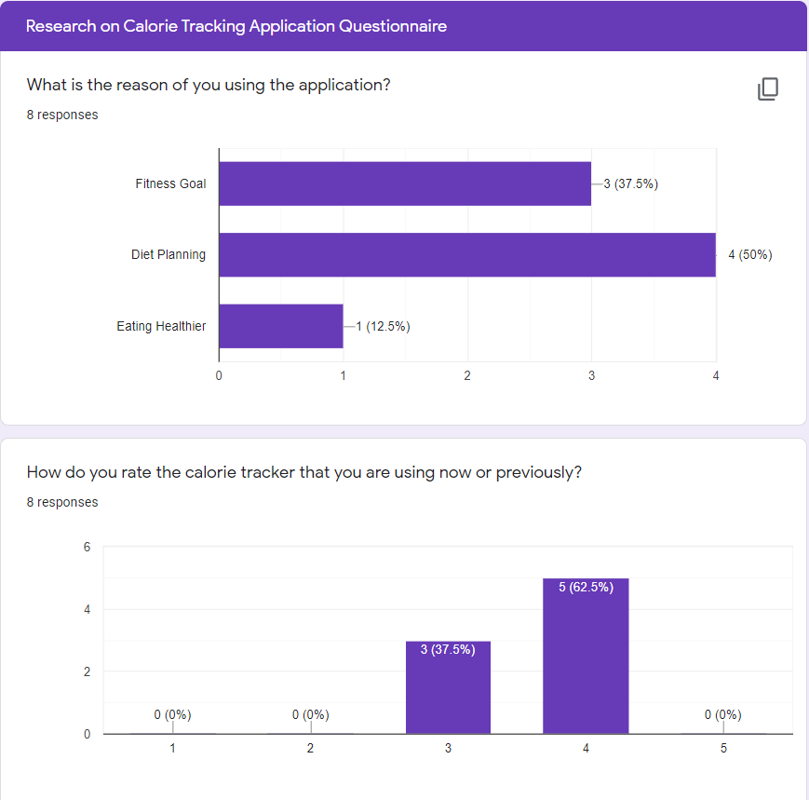

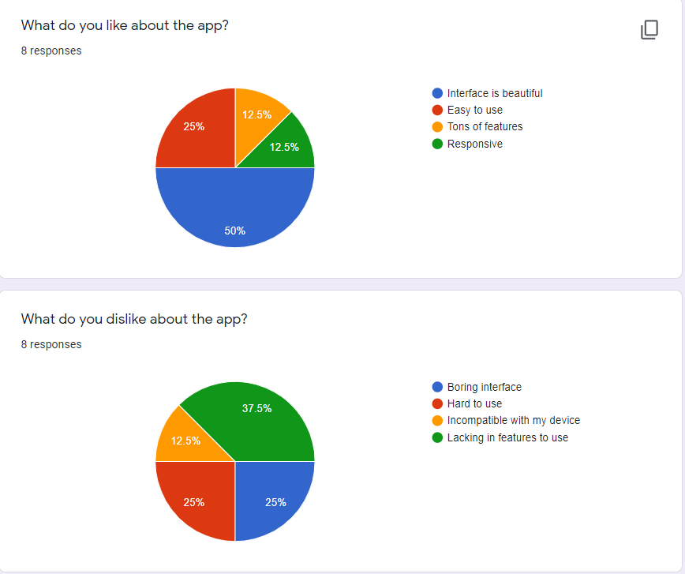

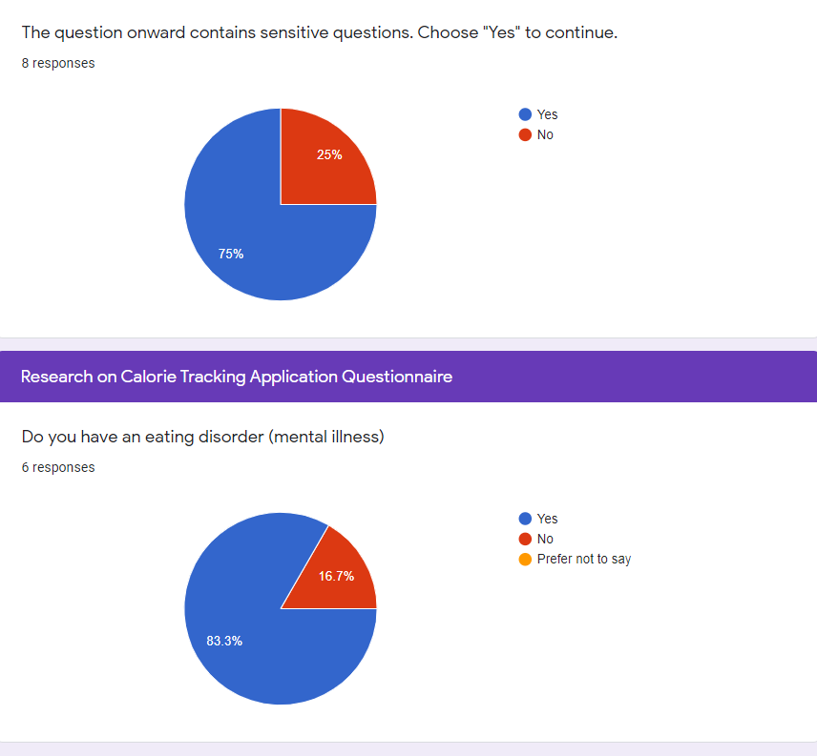 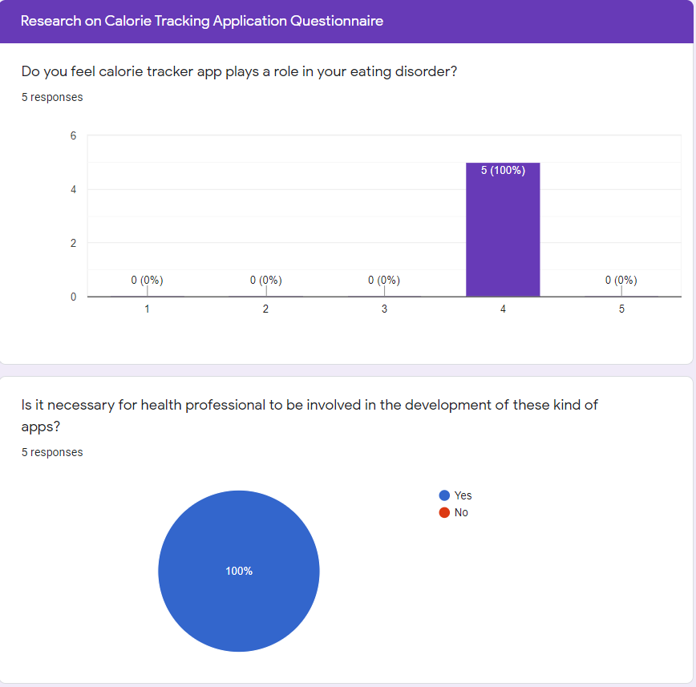

Appendixes D: Paper Prototype

Appendixes E: Final Design of the Interface

Login Page

Registration Page

Entering Daily Activities or Food Intake Page

Result Page